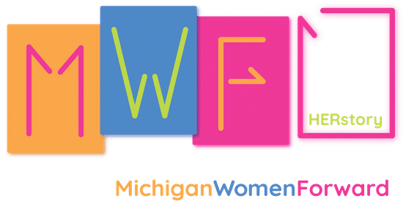
Internship Announcement
HERstory Museum
(Michigan Women’s Historical Center and Hall of Fame)
105 W Allegan St., Lansing, MI

Title: HERstory Museum Internship

Focus of Skills: Educational programming, exhibit installation, marketing and design, research

Description: Michigan Women Forward, a nonprofit that promotes and supports Michigan women, merged with the Michigan Women’s Historical Center and Hall of Fame (MWHOF) in March 2018 and is now called HERstory. HERstory is looking for an intern for the Summer of 2021. This person should be committed to learning about and striving for gender and racial equity in Michigan. Intern will work closely with Meaghan Bergman, the Program Director of HERstory, and other employees of Michigan Women Forward.

Duties Include:
- Availability to be in the museum at least 1 day a week
- Creating and installing new museum exhibits
- Designing social media posts and content for HERstory
- Researching history of Michigan women and groups supporting Michigan women
- Creating presentations based on research
- Updating digital exhibit of the Hall of Fame Inductees using Canva
- Updating Past Perfect Database

Requirements:
- Good organizational skills
- Interpersonal skills
- Excellent writing skills (can draft emails quickly and easily)
- Detailed researcher
- Proficient in Excel, Canva, social media platforms, Power Point, virtual conferencing platforms (Zoom, Teams, etc.) & other virtual/digital educational programming tools
- Creative and skilled in design
- Eager to learn about Michigan Women’s History and gender and racial equity!

If interested, please email resume and a cover letter outlining why you want to be our HERstory intern to Meaghan Bergman at mbergman@miwf.org.

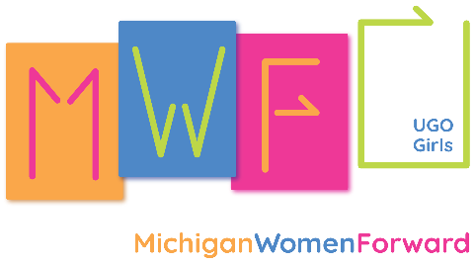
Internship Announcement
UGOGirls Summer 2021
Virtual internship

Title: UGOGirls Youth Empowerment & Leadership Programs Intern

Focus of Skills: Educational programming, marketing and design, program organization and management, mentorship, facilitation of programming

Description: Michigan Women Forward, a nonprofit that promotes and supports Michigan women and girls, is looking for a person committed to learning about and striving for gender and racial equity in Michigan to intern with the UGOGirls programs for Summer 2021. Intern will work closely with Meaghan Bergman, the Program Director of UGOGirls, and other employees of Michigan Women Forward.

Duties Include:
- Full-time availability the weeks of June 21-July 1 and July 26-August 5 (program dates)
- Part-time availability the other weeks of May 24-August 27
- Designing social media posts and content for UGOGirls
- Designing, organizing, and facilitating video testimonials of UGOGirls participants
- Curriculum & supplementary content design & editing
- Facilitation of curriculum & content within a virtual platform
- Relationship building with the participants and communication with families via email, phone, Edmodo, social media, etc.

Requirements:
- Passionate about gender & racial equity and mentoring the next generation of women leaders
- Good organizational skills
- Interpersonal skills
- Excellent writing skills (can draft emails quickly and easily)
- Proficient in Excel, Canva, social media platforms, Power Point, virtual conferencing platforms, & other virtual/digital educational programming tools
- Creative and risk taking with curriculum and content design
- Eager to learn about how to create and facilitate gender and racial equity programming!

If interested, please email resume and a cover letter outlining why you want to be our UGOGirls intern to Meaghan Bergman at mbergman@miwf.org.

